CS 305 Module Two Coding Assignment

Run Dependency Check

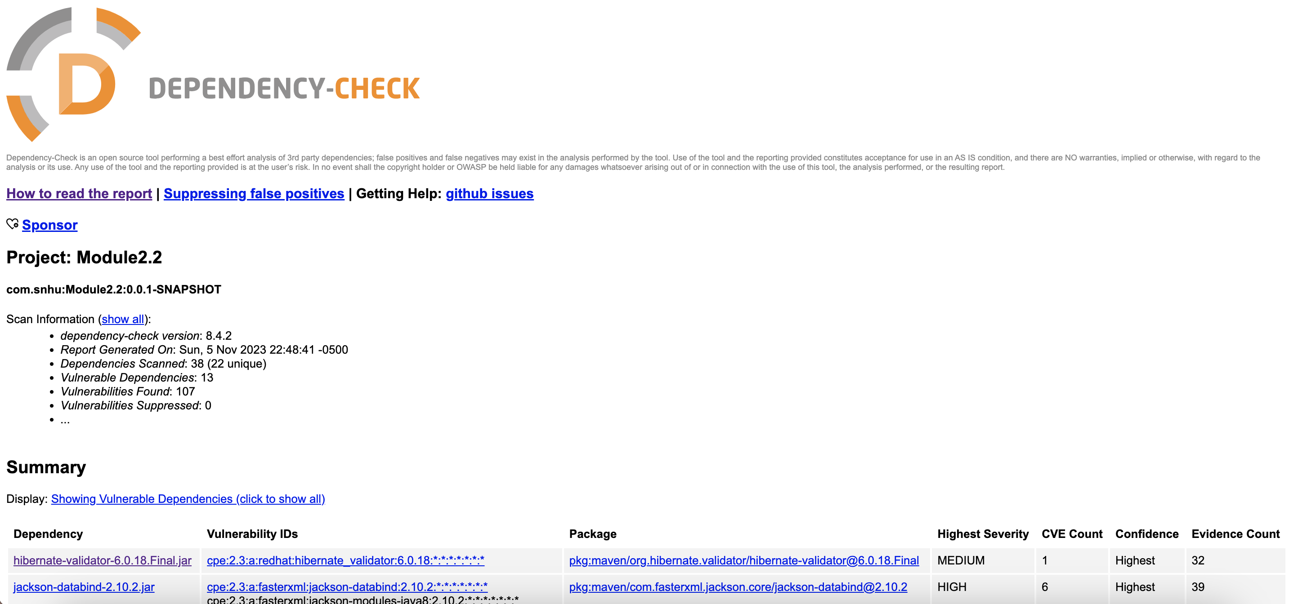

Document Results

- hibernate-validator-6.0.18.Final.jar
Description: Hibernate's Bean Validation (JSR-380) reference implementation.
License: http://www.apache.org/licenses/LICENSE-2.0.txt
- jackson-databind-2.10.2.jar
Description: General data-binding functionality for Jackson: works on core streaming API
License: http://www.apache.org/licenses/LICENSE-2.0.txt
- log4j-api-2.12.1.jar
Description: The Apache Log4j API
License: https://www.apache.org/licenses/LICENSE-2.0.txt
- logback-core-1.2.3.jar
Description: logback-core module
License: http://www.eclipse.org/legal/epl-v10.html, http://www.gnu.org/licenses/old-licenses/lgpl-2.1.html
- mongo-java-driver-2.4.jar
Description: Java Driver for MongoDB
License: The Apache Software License, Version 2.0: http://www.apache.org/licenses/LICENSE-2.0.txt
- snakeyaml-1.25.jar
Description: YAML 1.1 parser and emitter for Java
License: Apache License, Version 2.0: http://www.apache.org/licenses/LICENSE-2.0.txt
- spring-boot-2.2.4.RELEASE.jar
Description: Spring Boot
License: Apache License, Version 2.0: https://www.apache.org/licenses/LICENSE-2.0
- spring-boot-starter-web-2.2.4.RELEASE.jar
Description: Starter for building web, including RESTful, applications using Spring MVC. Uses Tomcat as the default embedded container
License: Apache License, Version 2.0: https://www.apache.org/licenses/LICENSE-2.0
- spring-core-5.2.3.RELEASE.jar
Description: Spring Core
License: Apache License, Version 2.0: https://www.apache.org/licenses/LICENSE-2.0
- spring-web-5.2.3.RELEASE.jar
Description: Spring Web
License: Apache License, Version 2.0: https://www.apache.org/licenses/LICENSE-2.0
- spring-webmvc-5.2.3.RELEASE.jar
Description: Spring Web MVC
License: Apache License, Version 2.0: https://www.apache.org/licenses/LICENSE-2.0
- tomcat-embed-core-9.0.30.jar
Description: Core Tomcat implementation
License: Apache License, Version 2.0: http://www.apache.org/licenses/LICENSE-2.0.txt
- tomcat-embed-websocket-9.0.30.jar
Description: Core Tomcat implementation
License: Apache License, Version 2.0: http://www.apache.org/licenses/LICENSE-2.0.txt

Analyze Results

- hibernate-validator-6.0.18.Final.jar – A bug in the message interpolation processor enables invalid EL expressions to be evaluated as if they were valid. This flaw allows attackers to bypass input sanitation (escaping, stripping) controls that developers may have put in place when handling user-controlled data in error messages.
- jackson-databind-2.10.2.jar - A flaw was found in FasterXML Jackson Databind, where it did not have entity expansion secured properly. This flaw allows vulnerability to XML external entity (XXE) attacks. The highest threat from this vulnerability is data integrity.
- log4j-api-2.12.1.jar - Improper validation of certificate with host mismatch in Apache Log4j SMTP appender. This could allow an SMTPS connection to be intercepted by a man-in-the-middle attack which could leak any log messages sent through that appender.
- logback-core-1.2.3.jar - In logback version 1.2.7 and prior versions, an attacker with the required privileges to edit configurations files could craft a malicious configuration allowing to execute arbitrary code loaded from LDAP servers.
- mongo-java-driver-2.4.jar - Specific versions of the Java driver that support client-side field level encryption (CSFLE) fail to perform correct host name verification on the KMS server’s certificate. This vulnerability in combination with a privileged network position active MITM attack could result in interception of traffic between the Java driver and the KMS service rendering Field Level Encryption ineffective.
- snakeyaml-1.25.jar - SnakeYaml's Constructor() class does not restrict types which can be instantiated during deserialization. Deserializing yaml content provided by an attacker can lead to remote code execution.
- spring-boot-2.2.4.RELEASE.jar - In Spring Boot versions 3.0.0 - 3.0.5, 2.7.0 - 2.7.10, and older unsupported versions, an application that is deployed to Cloud Foundry could be susceptible to a security bypass.
- spring-boot-starter-web-2.2.4.RELEASE.jar - In Spring Boot versions 3.0.0 - 3.0.5, 2.7.0 - 2.7.10, and older unsupported versions, an application that is deployed to Cloud Foundry could be susceptible to a security bypass.
- spring-core-5.2.3.RELEASE.jar - A Spring MVC or Spring WebFlux application running on JDK 9+ may be vulnerable to remote code execution (RCE) via data binding.
- spring-web-5.2.3.RELEASE.jar - Pivotal Spring Framework through 5.3.16 suffers from a potential remote code execution (RCE) issue if used for Java deserialization of untrusted data. Depending on how the library is implemented within a product, this issue may or not occur, and authentication may be required.
- spring-webmvc-5.2.3.RELEASE.jar - A Spring MVC or Spring WebFlux application running on JDK 9+ may be vulnerable to remote code execution (RCE) via data binding.
- tomcat-embed-core-9.0.30.jar - When using the Apache JServ Protocol (AJP), care must be taken when trusting incoming connections to Apache Tomcat. Tomcat treats AJP connections as having higher trust than, for example, a similar HTTP connection. If such connections are available to an attacker, they can be exploited in ways that may be surprising.
- tomcat-embed-websocket-9.0.30.jar - When using the Apache JServ Protocol (AJP), care must be taken when trusting incoming connections to Apache Tomcat. Tomcat treats AJP connections as having higher trust than, for example, a similar HTTP connection. If such connections are available to an attacker, they can be exploited in ways that may be surprising.

